E-Paper - Display Images

Materials

* AmebaD [ [AMB23](https://www.amebaiot.com/amebad/#rtk_amb23) / [AMB21](https://www.amebaiot.com/amebad/#rtk_amb21) / [AMB22](https://www.amebaiot.com/amebad/#rtk_amb22) / [BW16](https://www.amebaiot.com/amebad/#partner_bw16) ] x 1
* Waveshare 2.9inch E-Paper HAT (D) x 1

Example

In this example, we use the Ameba RTL8722 module to connect to a Waveshare 2.9-inch e-Paper module to display a few QR codes. The display uses the flexible substrate as base plate, with an interface and a reference system design.  
The 2.9” active area contains 296 x 128 pixels and has 1-bit white/black full display capabilities. An integrated circuit contains gate buffer, source buffer, interface, timing control logic, oscillator, etc… are supplied with each panel.  
You may refer to the official [2.9 inch e-Paper HAT(D) datasheet](https://www.waveshare.net/w/upload/b/b5/2.9inch_e-Paper_(D)_Specification.pdf) to know more information about this module. Front view of the e-Paper Module:

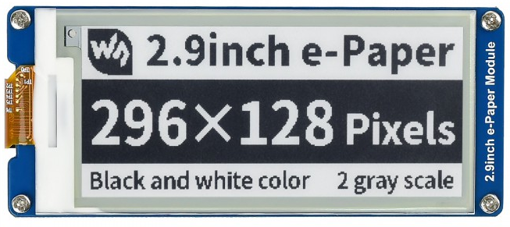

**AMB21/AMB22 wiring diagram:**

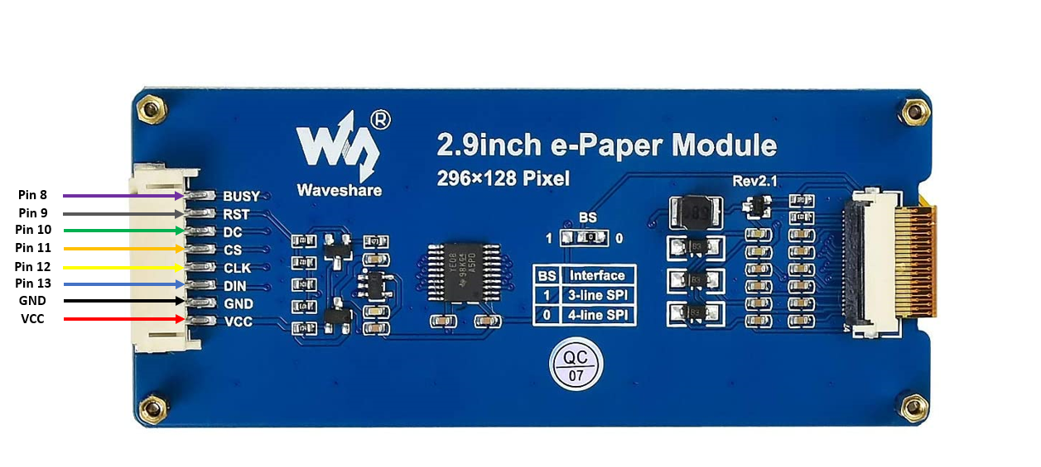

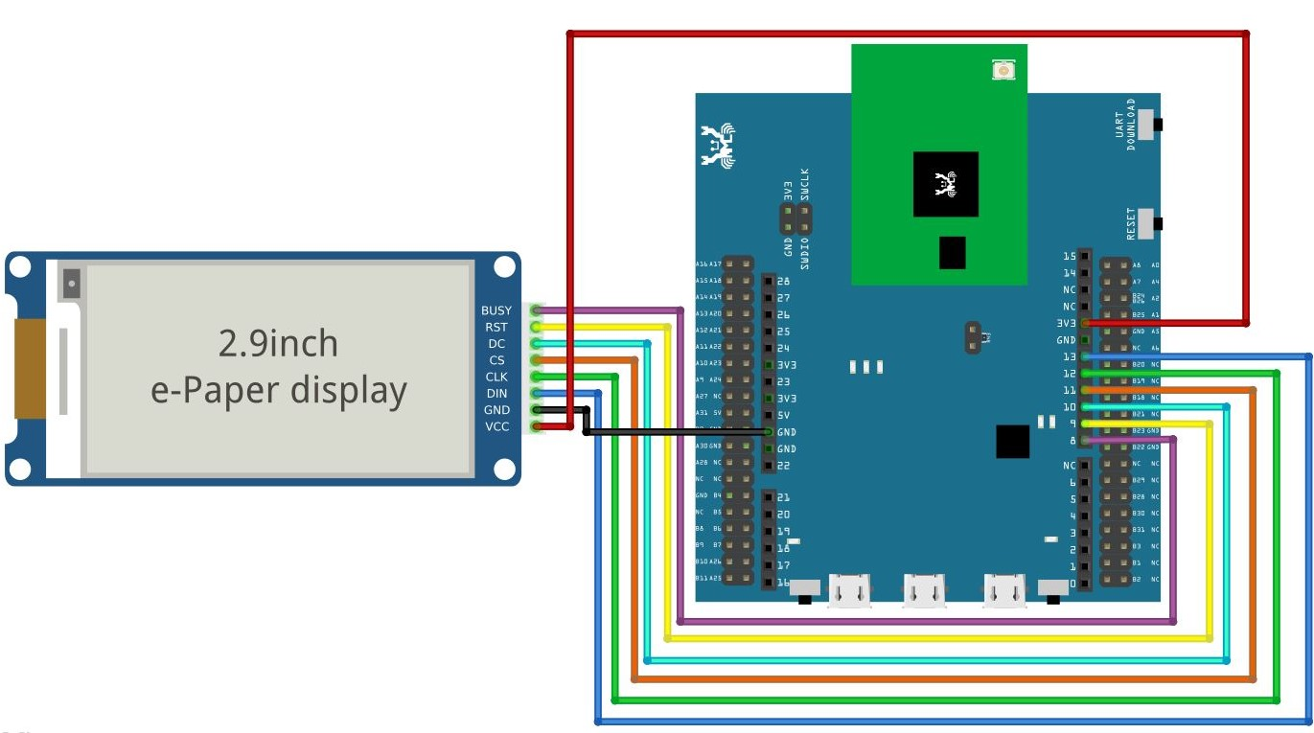

**AMB23 wiring diagram:**

**BW16 Wiring Diagram:**

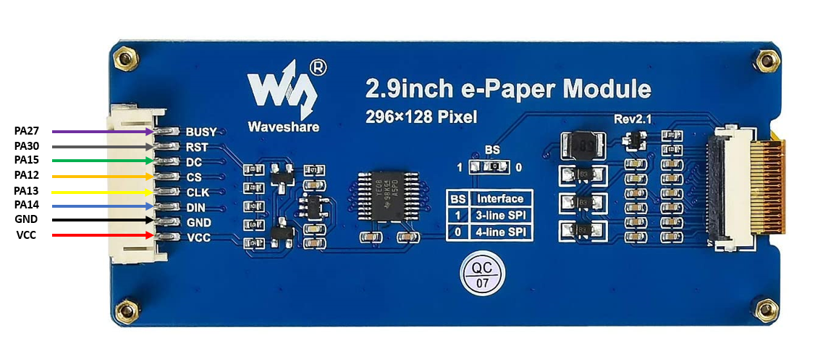

**BW16-TypeC Wiring Diagram:**

Firstly, you need to prepare a picture/photo in the format of 296×128 pixels. We can easily find a photo resizing tool online, for example, the [Online Image Resizer](https://resizeimage.net/).

Following the instructions on the website, then download the generated image in JPG format.

Secondly, we use the [Image2LCD](http://www.waveshare.net/w/upload/3/36/Image2Lcd.7z) tool to transfer the downloaded 296×128 image into hexadecimal codes. You can visit this [YouTube](https://www.youtube.com/watch?v=kAmnU5Y96MA&t=363s) link to get detailed instructions.

Download the Eink zip library, AmebaEink.zip, at <https://github.com/ambiot/ambd_arduino/tree/master/Arduino_zip_libraries>  
Then install the AmebaEink.zip. Open the “DisplayQR” example in “File” → “Examples” → “AmebaEink” → “EinkDisplayImage”:

Press the reset button after uploading the sample code, you will need to wait for around 1-2 seconds for the e-Paper module to fresh its screen. Then the screen will start to display an image for 5 seconds first, then 3 different QR codes will be displayed every 5 seconds (showing in the screenshot below, you may scan the QR codes and find out more information if you wish to). Lastly, a gif which comes in form of 3 frames will be displayed for a few seconds.

Code Reference

[1] We use Good Display GDEH029A1 2.9 Inch / 296×128 Resolution / Partial Refresh Arduino Sample Code to get the e-Paper successfully Display:  
<http://www.good-display.com/product/201.html>

[2] Provide the link to how to generate a QR code on the E-paper module:  
<https://eugeniopace.org/qrcode/arduino/eink/2019/07/01/qrcode-on-arduino.html>